**Settings**

1. I would move the selector to be inline with the label, not header like it’s with theme
2. Theme label has “onselect” property that launches github
3. Remove the free space between header and label?

And finally – settings dialog is not centered :P

What you could do as well parametrize the language as the URL param - so that you can open app with a specific language set by default ;) Eg.

[https://apps.powerapps.com/play/9b36872b-418e-4eb5-a336-66195bd4a083?tenantId=3f85db36-a3fc-4202-9c88-935090de98b9&source=portal&screenColor=rgba(219%2C%20219%2C%20219%2C%201)**&lang=Polski**](https://apps.powerapps.com/play/9b36872b-418e-4eb5-a336-66195bd4a083?tenantId=3f85db36-a3fc-4202-9c88-935090de98b9&source=portal&screenColor=rgba(219%2C%20219%2C%20219%2C%201)&lang=Polski)

**Popup components**

For some of the components the picture is displayed with the black line below, like if the crop canvas is 1px to high.

**Controls**

I would personally prefer to have the “FocusedBorderThickness” set to 0, as when I select a control and it gets surrounded by the border, it looks like it’s cut out from the app layout. But if that’s an accessibility requirement, it must stay 😉

**Members and owners**

1. Links should have a relative Y position. Like one link in PL is in two lines, and then spacing between labels is different.
2. I don’t know if you shouldn’t first let to choose owners and then members. And in general to first mention owners, then members, then guests.

1. Not translated
2. Not translated

When a user first selects that they want to add guests and then selects to “I don’t want to add members nor owners” guests’ form is still enabled. Either hide it or make disabled like the rest of controls.

**Channels**

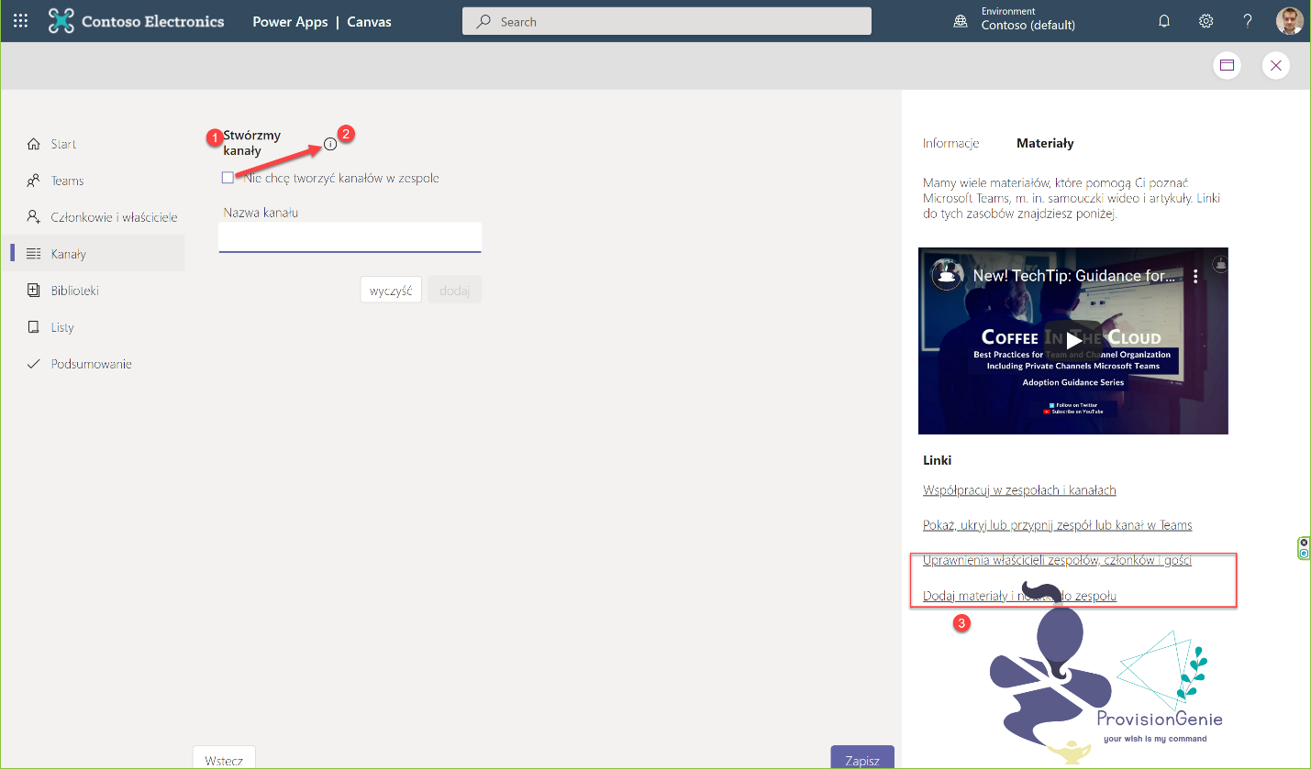

1. Label has fixed width
2. When checkbox to not create channels is selected, hint disappears.
3. Maybe add some blur background, so that even when it hovers the logo, it makes the content still readable?

**Libraries**

1. Label is not inheriting theme
2. I understand that ticking is meant to first check if there’s anything already created with that name, however it took me a while to figure out I need to click it. Why not add buttons like at the screen with Channels or Members? Just a button to explicitly tell user they must click it? At first I thought that library will be either created when I blur the field or… And that checkmark is a validation – ok or not ok.

The same when a “choice” column is selected – adding option choices should be done through a button too.

1. Buttons are switched – “Next” when library is created and “Save” when checkbox is selected.
2. No logo? By purpose?

1. No translations
2. No translations
3. Fixed width

1. Component shown after clicking “Save” on libraries page does not cover whole canvas plus it’s not centered.
2. There’s a space missing after single quote surrounding name of the library.

**Lists**

1. Not translated
2. The same issue like for libraries. When “I don’t want to create list” option is selected, button displays “Save”, otherwise “Next”. Should be the other way round.
3. Fixed width
4. No logo?
5. Please replace tick marks with buttons. It really looks like a field’s validation, not a button to click.

Field remains active when checkbox is selected.

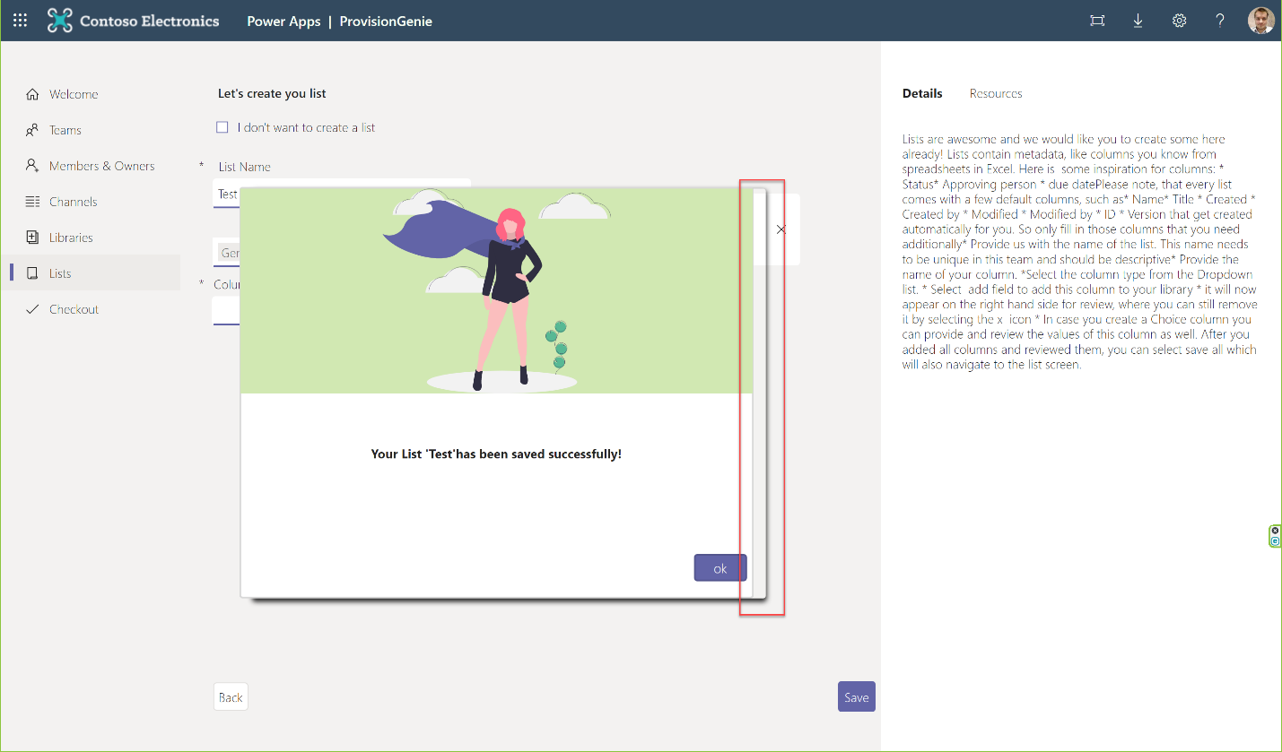

Save modal does not cover canvas with semitransparent background plus its somehow wrongly formatted.

**Checkout**

1. Fixed width of the button
2. Modal is not overing the whole canvas and is not centered.

1. Not inline ☹
2. Also, it looks a bit crowded, there should be more space between the label and buttons.